Contents
1.0 User story of Solar home 3
2.0 Wire frames & UI requirements: 4
3.0 Workflows 6

1.0 User story of Solar home
Title: Existing user login
As a: | Existing user
I want to: | Have an ability to login in the Application
So that: | I can use service of Solar home
Acceptance  Criteria: | - On a home page system shall display a Login/click button (referring Wireframe 1: Home page)  - On a click on Login button system shall open login page (referring Wireframe 2: Login page)  - On a Login Page system shall display mandatory Fields (referring Wireframe 2: login Page)  - Phone Number: System Shall allow user to write registered Phone number  - Password: System shall allow user to add password in the form of Alphanumeric with special character  - After filling the above mentioned Mandatory fields system shall Allow user to click on a login button  - After click on Login button system shall validate data and if data is correct then system will allow user to login in Solar home application.  - Alternate Flow 1: After clicking the Login button system validates data and If added phone number is not registered then system shall display error in the Phone number field, system shall allow user to re-enter registered phone number (referring work flow 1: Existing user Login)  - Alternate Flow 2: After clicking the Login button system validates data and If Password is incorrect then system shall display error in the field of Password, system shall allow user to re-entered password (referring work flow 1: Existing user Login)

2.0 Wire frames & UI requirements:
Wire frame 1: Home Page

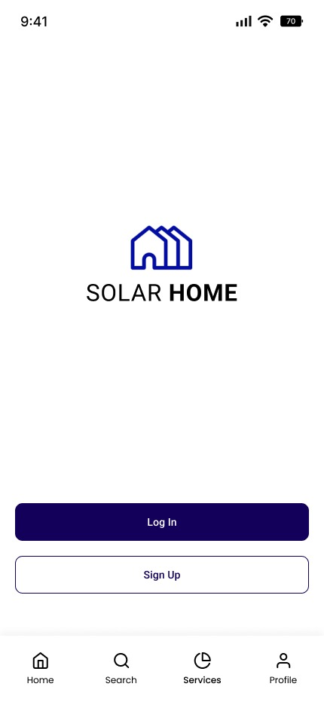

ID | Field Name | Field Type | Content | Default  Selection
1 | Login | Button | After click on Login button system shall open new page where existing user fill Mandatory fields to Login | N/A

Wire Frame 2: Login Page
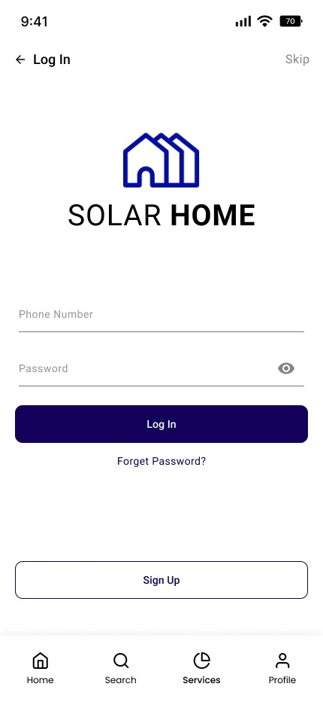

ID | Field Name | Field Type | Content | Default  Selection
1 | Phone Number | Numeric | User shall add registered Phone number to login | N/A
2 | Password | Alphanumeric  With special character | user shall add correct password to login | N/A
3 | Login | Button | On a click system shall allow user to log in after validate the data | N/A
4 | Forget  Password | Link Button | On a click system shall open new page, user can add mandatory data retrieve password | N/A
5 | Sign up | Button | On a click new user can register | N/A

3.0 Workflows
3.1 Existing User Login Flow 1: 